NYS
Real Property Tax Relief Credit - Form IT-229
You qualify for this credit if you meet any of the following:
- you were a NYS resident for the full tax year
- you owned and primarily resided for six months or more of the tax year in real property that
received the STAR exemption, or you qualified you for the STAR credit at the property
- you make less than $250,000 annually and pay more than 6% of income toward property
taxes
How much is the credit?
- you may claim the credit on one property only
- if eligible, you may claim a credit of between $250 to $350
- if the calculation of the credit exceeds $350, the homeowner can get only $350. Also, if the
calculation is less than $250, the homeowner WILL NOT get the credit
- currently this credit is only available through 2023

How is your credit calculated? (See examples below)
- A homeowner makes $50000 this year and pays $5000 in property taxes.
6% of $50000 is $3000, which means the homeowner paid $2000 in excess property taxes
14% of $2000 is $280, which means the homeowner would get a credit of $280.

- A homeowner makes $50000 this year and pays $2000 in property taxes.
6% of $50000 is $3000, which means the homeowner did not pay any excess property taxes, which means that they are not eligible for the credit.

C) If your income is more than $75000, please see the image below to calculate the credit:
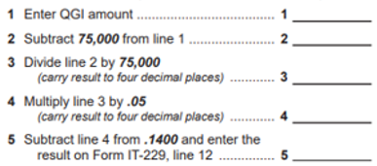

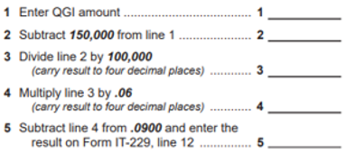
D) If your income is more than $150000, please see the image below to calculate the credit:

